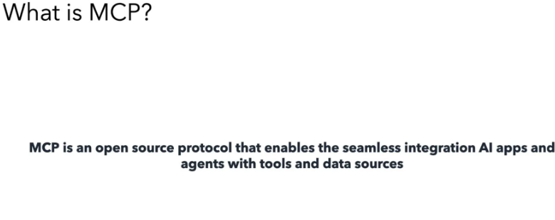

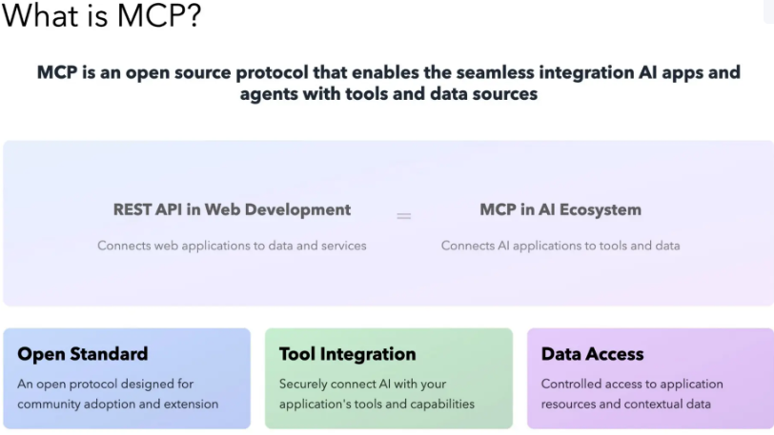

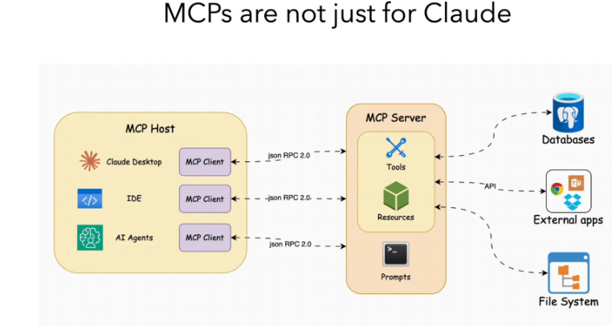

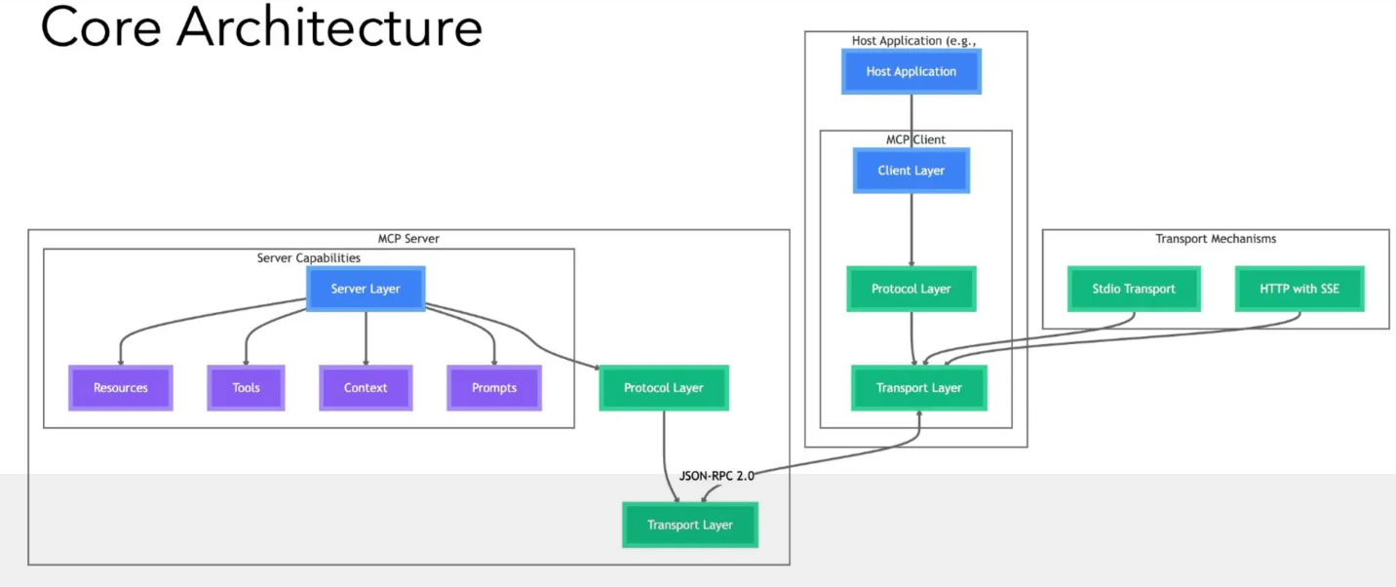

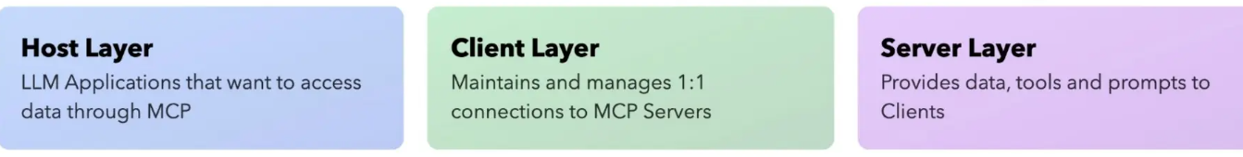 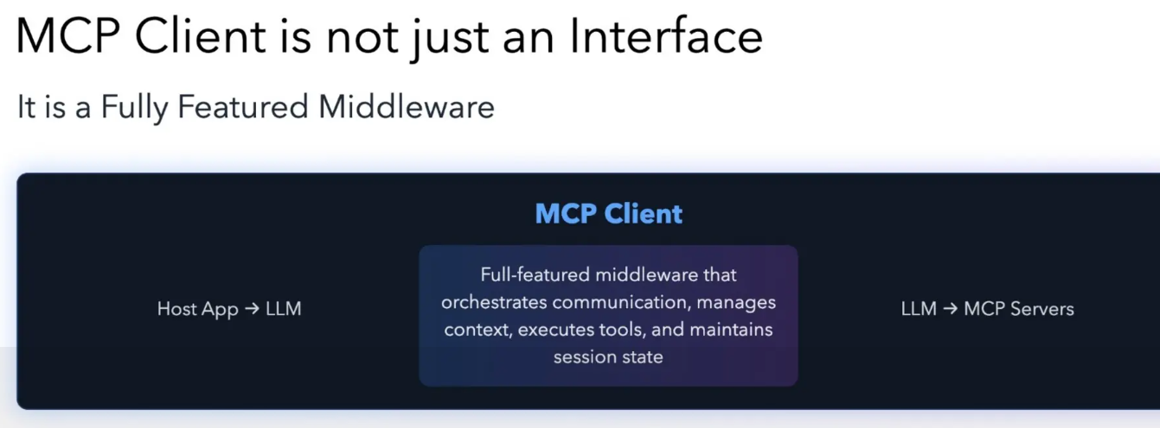

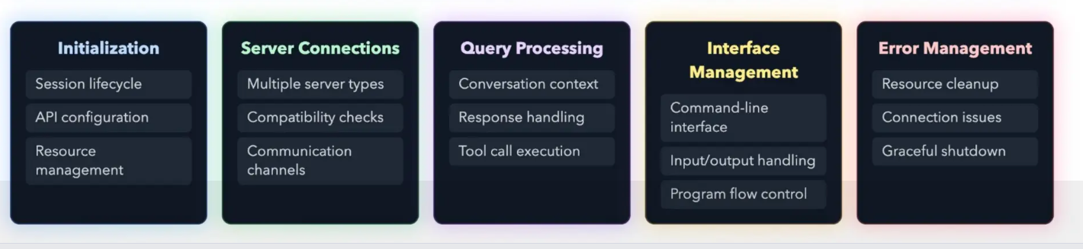

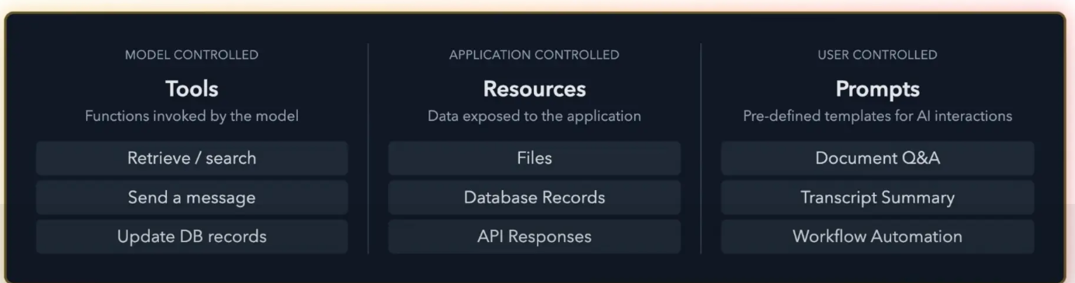

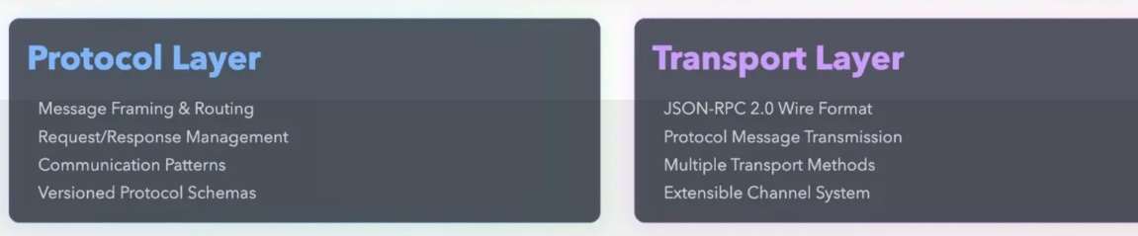

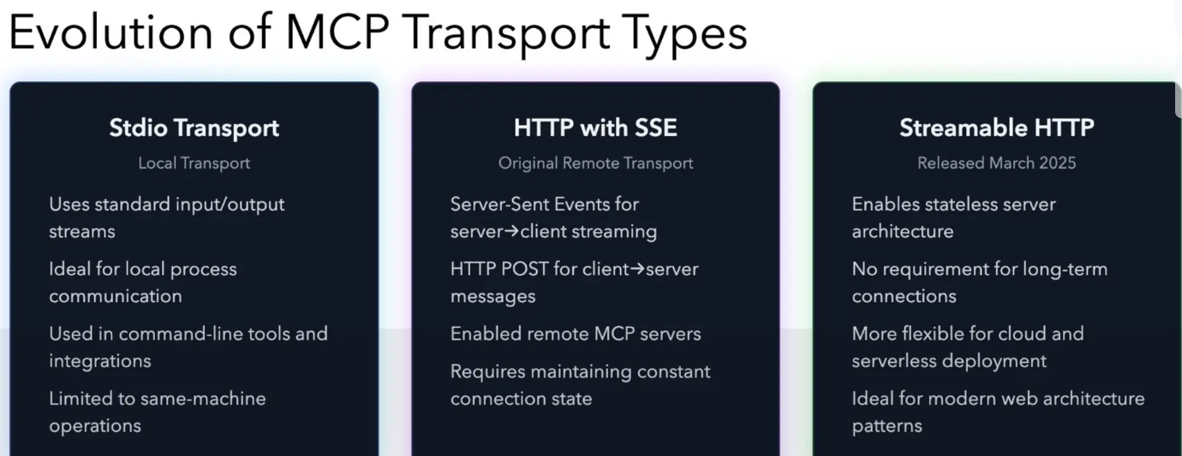

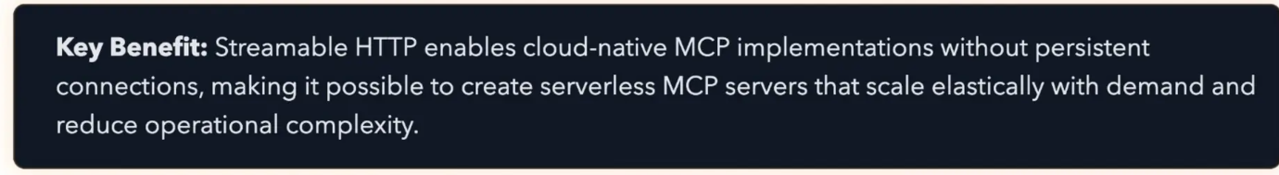

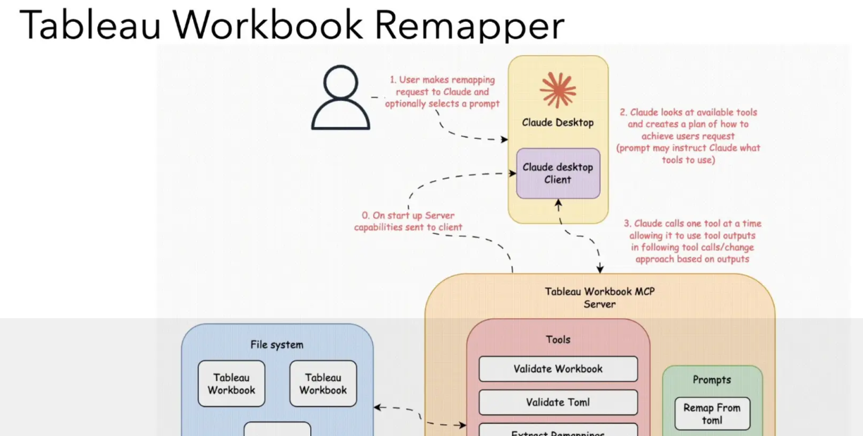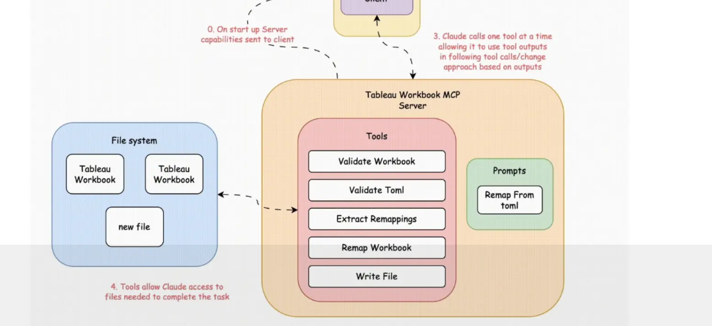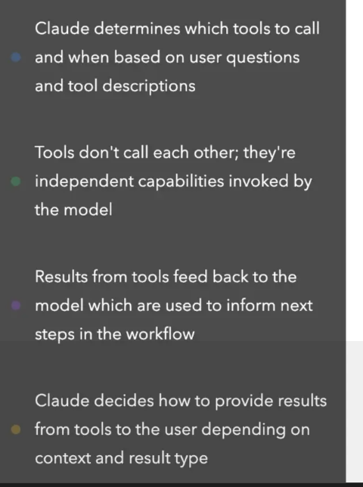

Sampling in MCP

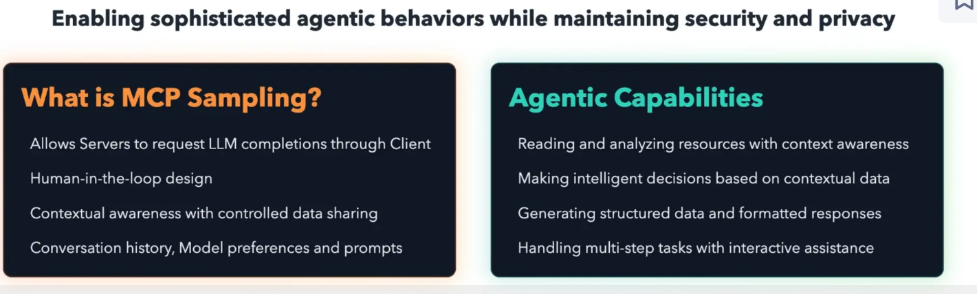

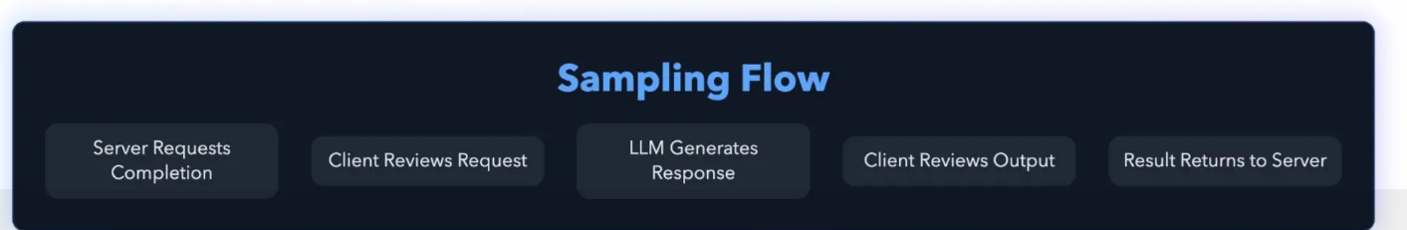

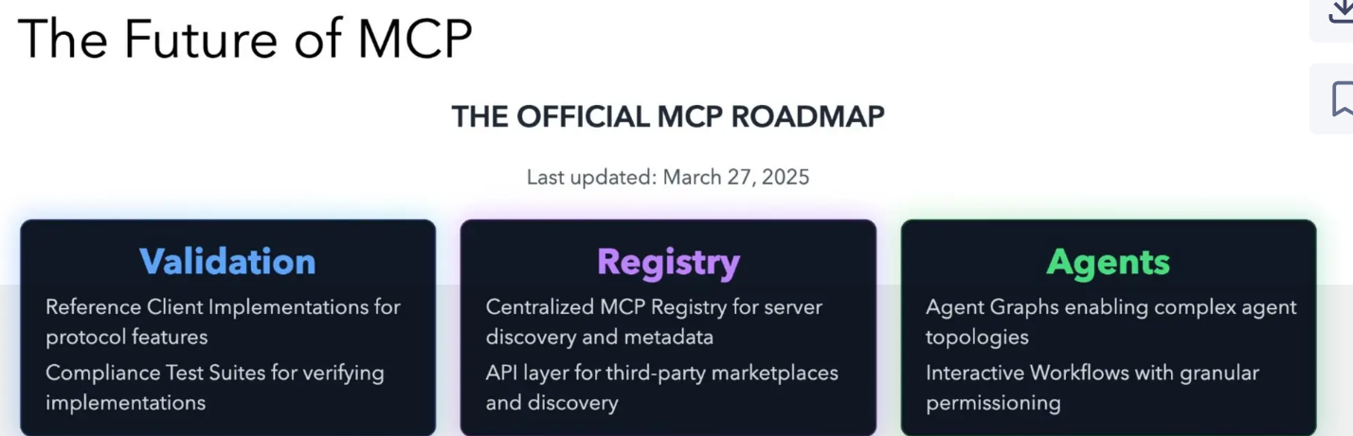

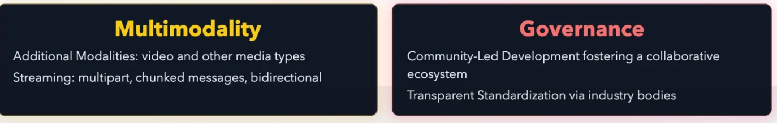

Other

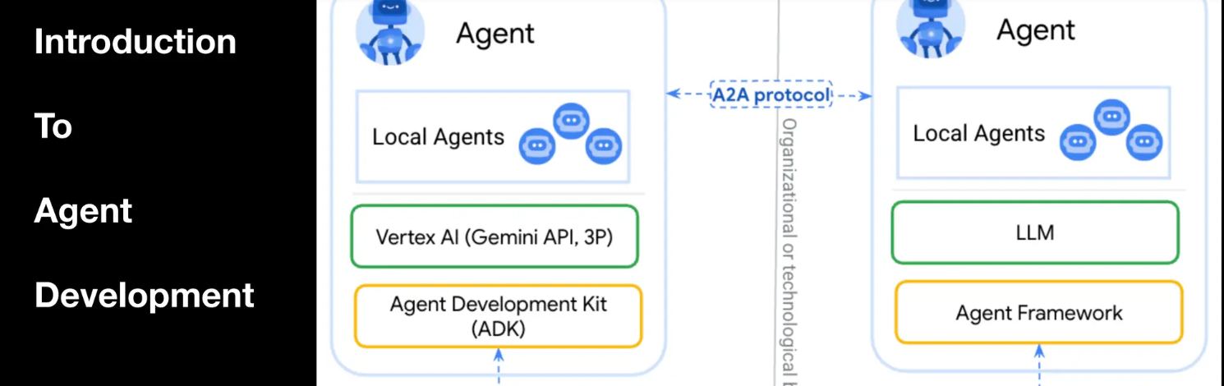

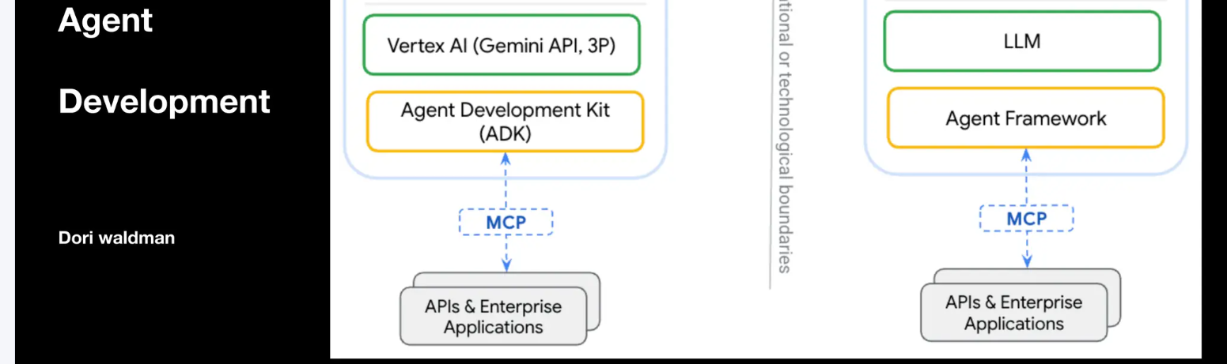

Agent Desc

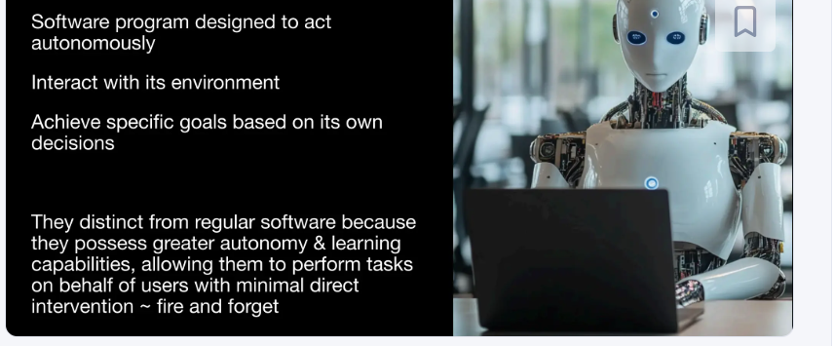

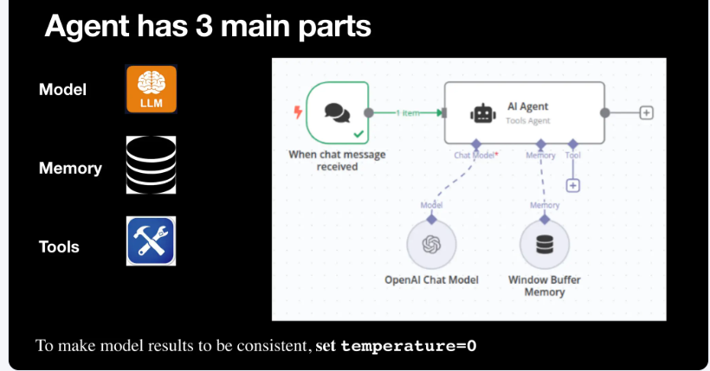

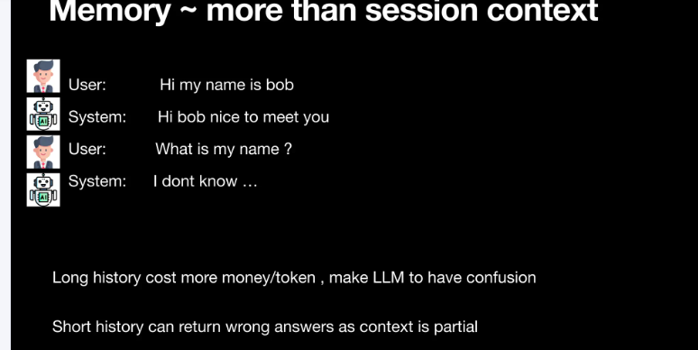

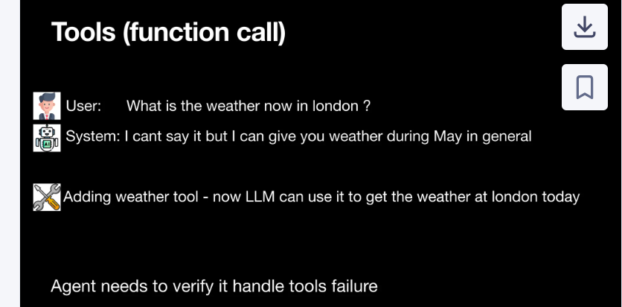

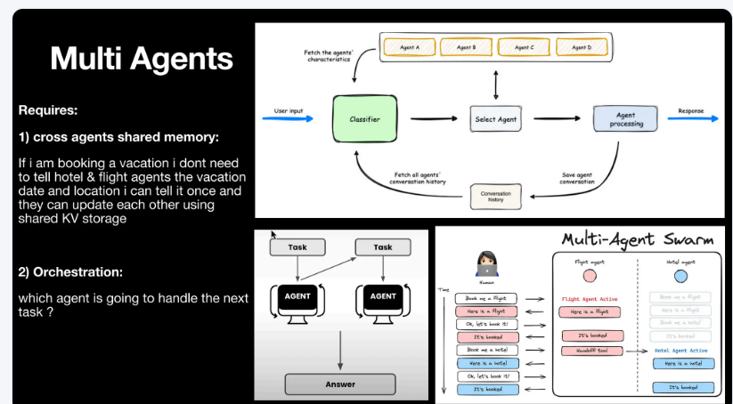

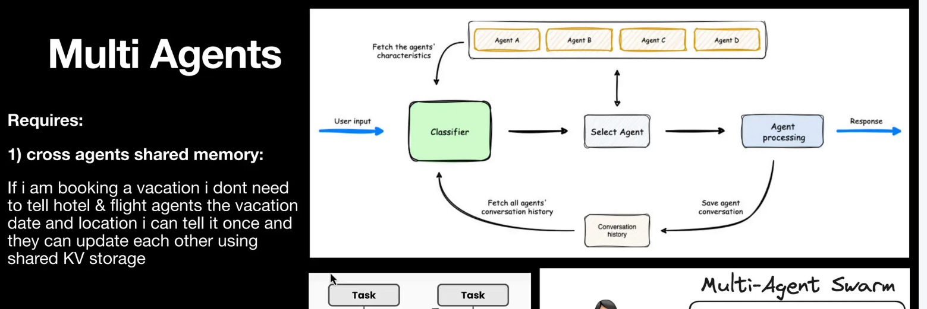

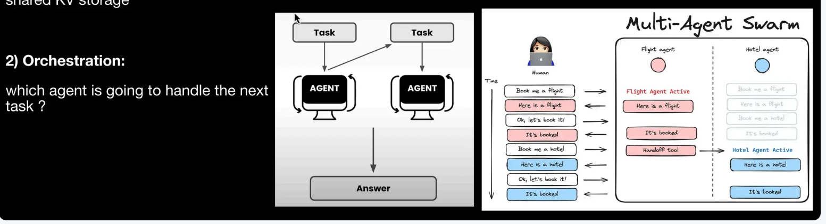

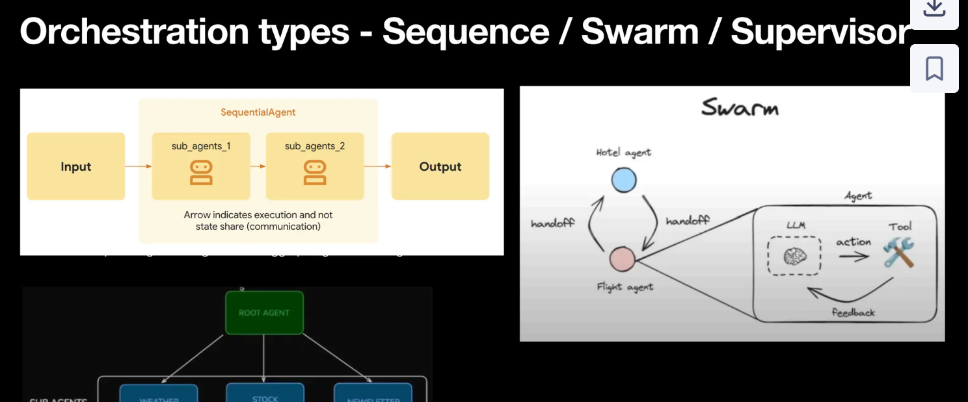

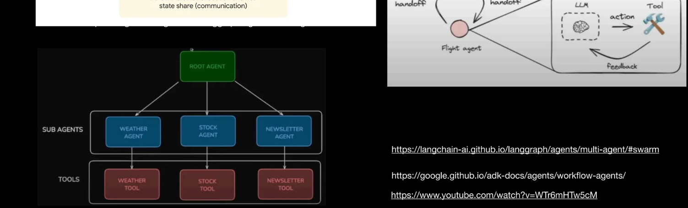

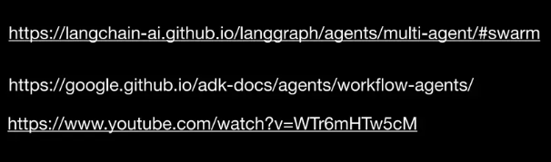

https://langchain-ai.github.io/langgraph/agents/multi-agent/#swarm

https://google.github.io/adk-docs/agents/workflow-agents/ <https://www.youtube.com/watch?v=WTr6mHTw5cM>

https://langchain-ai.github.io/langgraph/concepts/multi_agent/#multi-agent-architectures

https://pub.towardsai.net/supervisor-style-the-king-of-multi-agent-systems-139f0990ed17

https://medium.com/@siddharthc96/building-multi-agent-swarms-a-powerful-architecture-for-complex-ai-systems-37e8d7d9c0a5

MCp ~~ wrapper

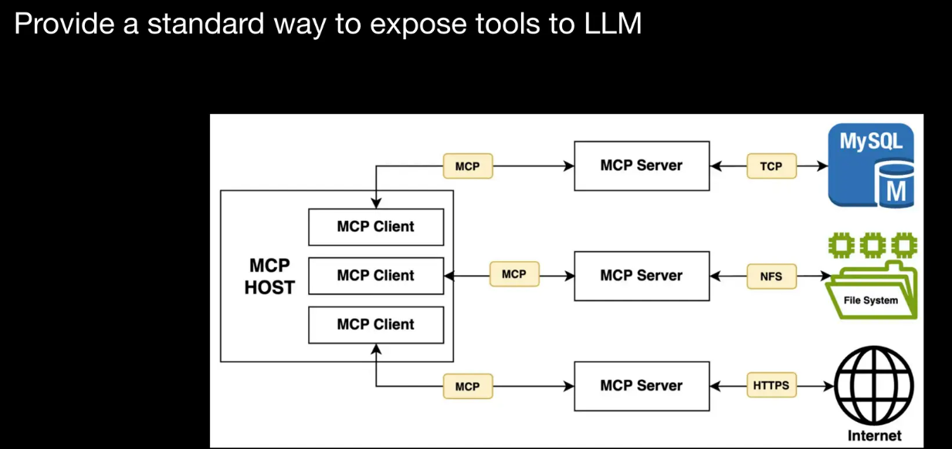

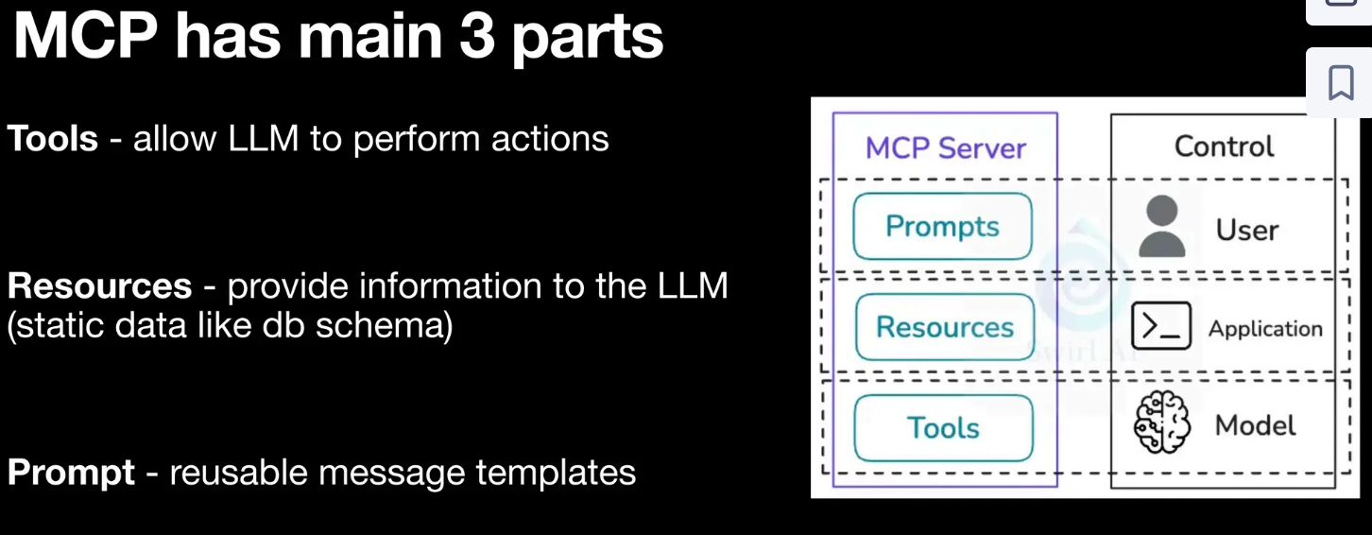

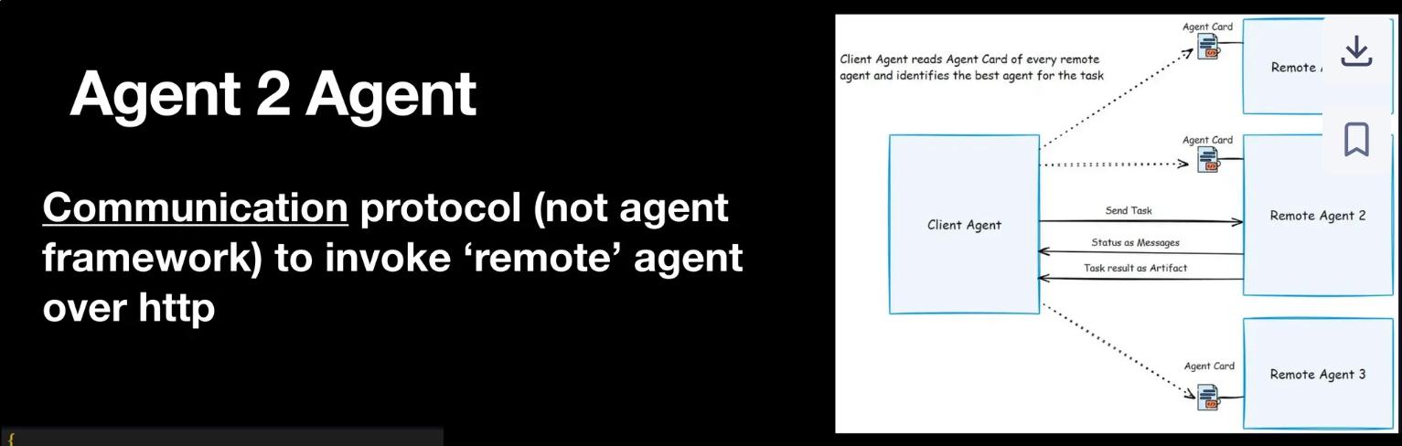

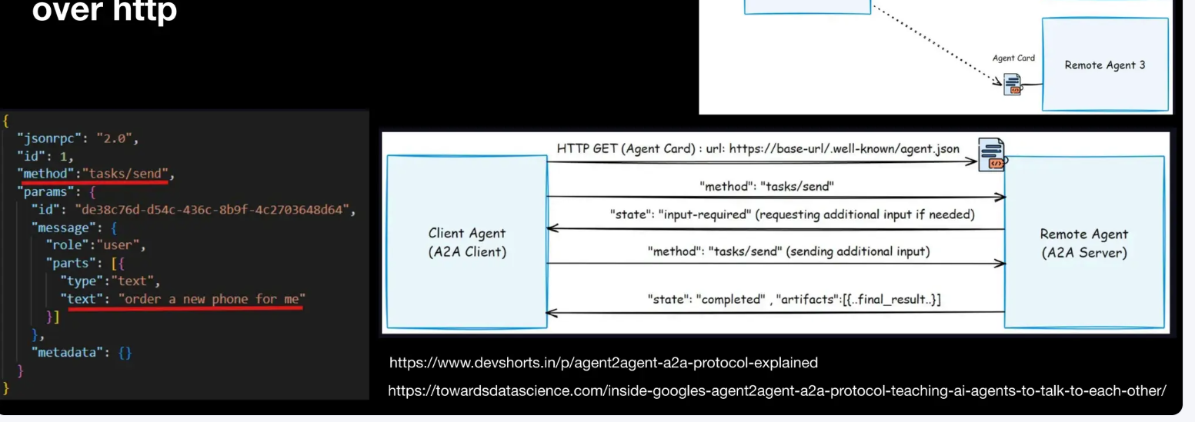

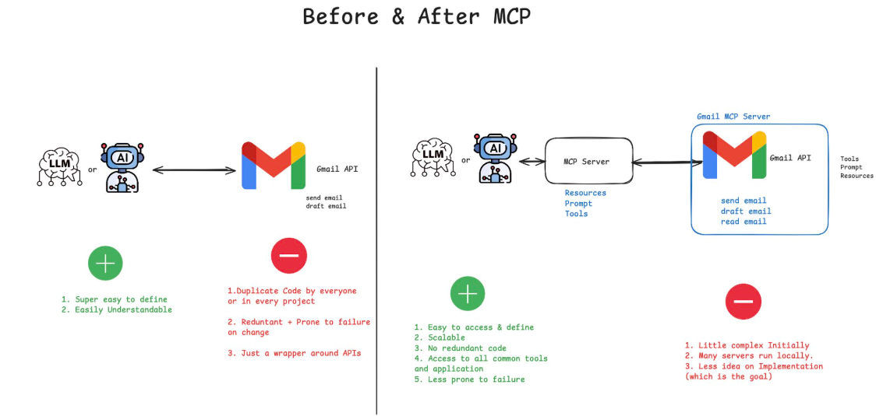

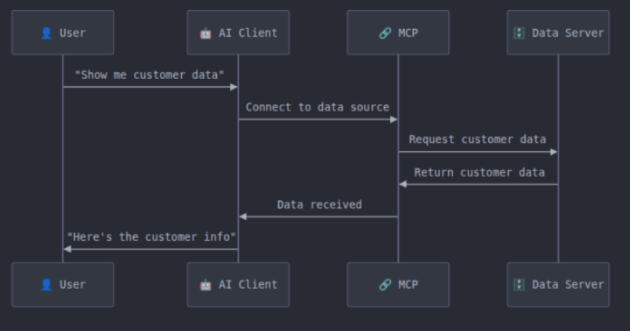

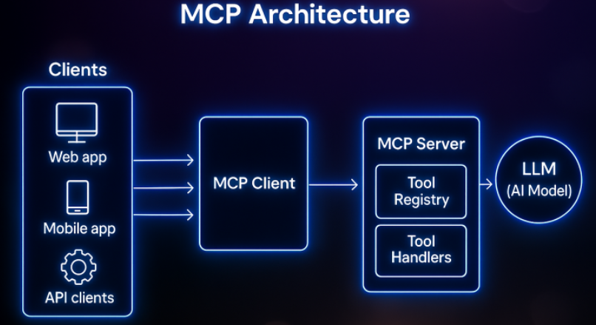

🔹 MCP (Model Context Protocol) → Think of it as a “common language” that lets [**hashtag#AI**](https://www.linkedin.com/search/results/all/?keywords=%23ai&origin=HASH_TAG_FROM_FEED) tools talk to apps and services.  
  
🔹 MCP Host -> The platform (like VS Code, Cursor, [**hashtag#Claude**](https://www.linkedin.com/search/results/all/?keywords=%23claude&origin=HASH_TAG_FROM_FEED) Desktop) that runs MCP.  
It’s like the “operating system” for AI integrations.  
  
🔹 MCP Server -> A plugin or backend that exposes tools/data (like a database, API, or file system).  
It provides the actual functionality.  
  
🔹 MCP Client -> The bridge that connects the host with the server.  
It’s what lets your AI assistant call those tools properly.  
  
✨ In simple words:  
  
Host = Where AI lives  
  
Server = Tools AI can use  
  
Client = Middleman connecting both

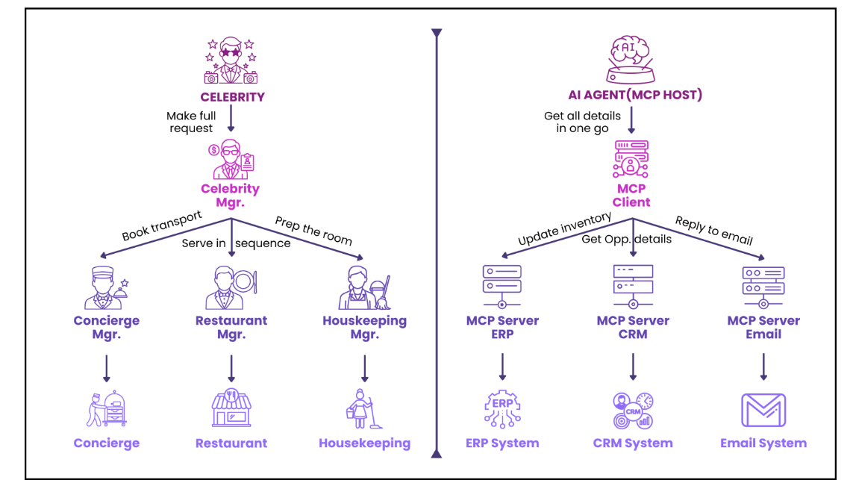

<https://www.linkedin.com/pulse/everything-you-wanted-know-mcp-were-afraid-ask-ekhlaque-bari-gfznc/?trackingId=A5btLK75SlCmbaDlnTFLyQ%3D%3D>

